Transparent Proxy
# Source: Chatgpt (GPT-5-Mini) at [1/16/2026]
A Transparent Proxy is a type of proxy server that intercepts network traffic without requiring any configuration on the client side.

🔍 Definition:
# Source: Chatgpt (GPT-5-Mini) at [1/16/2026]
A Transparent Proxy (also called an inline proxy or intercepting proxy) is "transparent" to the user — meaning the user’s device doesn’t know a proxy is involved. It automatically redirects traffic without requiring browser or system settings to be changed.

🧱 How It Works:
# Source: Chatgpt (GPT-5-Mini) at [1/16/2026]

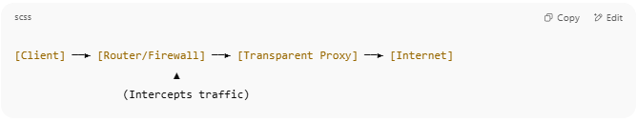

[Client] ──► [Router/Firewall] ──► [Transparent Proxy] ──► [Internet]
▲
(Intercepts traffic)

- The user sends a request (e.g., http://example.com) thinking it goes directly to the site.
- The network device (like a firewall or router) silently redirects it to the Transparent Proxy.
- The proxy processes or filters the request (e.g., for caching or blocking).
- It then sends the request to the actual destination and returns the response to the user.

🔐 Why It's Called "Transparent":
# Source: Chatgpt (GPT-5-Mini) at [1/16/2026]
- Transparent to the client: The user doesn’t need to know or configure anything.
- The proxy automatically intercepts traffic at the network level.

📌 Common Uses:
# Source: Chatgpt (GPT-5-Mini) at [1/16/2026]
- Content Filtering (in schools, offices)
- Traffic Monitoring (track usage and enforce policies)
- Caching Web Content (to improve speed)
- Ad Insertion or Removal (by ISPs or firewalls)
- Bandwidth Saving

🚧 Pros and Cons:
# Source: Chatgpt (GPT-5-Mini) at [1/16/2026]


✅ Pros | ❌ Cons
No setup required on user devices | Can break websites using HTTPS
Centralized control over traffic | May cause privacy concerns
Useful for monitoring or filtering | Harder to implement securely

🔐 HTTPS and Transparent Proxies:
# Source: Chatgpt (GPT-5-Mini) at [1/16/2026]
- Transparent proxies cannot easily intercept HTTPS traffic without causing certificate errors unless they use SSL/TLS interception, which requires a trusted root certificate to be installed on the client.

🛠️ Tools That Can Be Used as Transparent Proxies:
# Source: Chatgpt (GPT-5-Mini) at [1/16/2026]
- Squid (configured with intercept)
- pfSense (with Squid package)
- iptables (Linux tool for redirecting traffic)
- Cisco Routers/Firewalls

